Software Review Plan

(Adaptive vs Responsive)

Rappid app development

Liam

Table of Contents

(Adaptive vs Responsive) 1

Software Review Plan 1

Goal of the Software Review plan 1

Process of Software review 1

Software Peer Review 2

Benefits of the Software Review 2

Bibliography 3

# Software Review Plan

A software review plan is a systematic inspection of code by one or more individuals who work together to correct errors and defects in the software during its early stages of (SDLC) Software development life cycle. Software review is integral to ensuring that the clients needs are met and that everything is operating how it should be.

Usually performed manually, software review is used to verify various documents like requirements, system designs, codes, test plans and test cases.

(geeksforgeeks, n.d.)

# Goal of the Software Review plan

* To improve the productivity of the development team.
* To make the testing process time and cost effective.
* To make the final software with fewer defects.
* To eliminate the inadequacies.

# Process of Software review

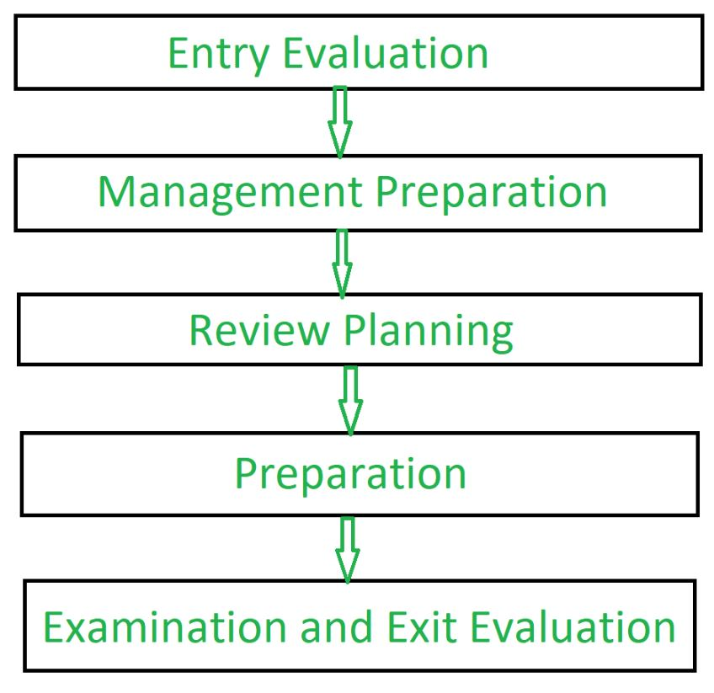

# **Software Peer Review**

The following form of Software review is what we will be closely following to ensure code is reviewed and inspected for functionality.

Software Peer Review:

Peer review is the process of assessing the technical content and quality of the product and it is usually conducted by the author of the work product along with some other developers.

Peer review is performed in order to examine or resolve the defects in the software, whose quality is also checked by other members of the team.

Peer Review has following types:

1. **Code Review**:

Computer source code is examined in a systematic way.

1. **Pair Programming**:

It is a code review where two developers develop code together at the same platform.

1. **Walkthrough:**

Members of the development team is guided bu author and other interested parties and the participants ask questions and make comments about defects.

1. **Technical Review:**

A team of highly qualified individuals examines the software product for its client’s use and identifies technical defects from specifications and standards.

1. **Inspection:**

In inspection the reviewers follow a well-defined process to find defects

# Benefits of the Software Review

* Defects and issues can be found early and corrected
* Earlier detection minimizes the cost both in time and money
* It can be used improve upon technical documentation
* Remove inferior ways of documenting and developing code.

# Bibliography

geeksforgeeks. (n.d.). *Software Engineering | Software Review*. Retrieved from geeksforgeeks: https://www.geeksforgeeks.org/software-engineering-software-review/